Name _________________________________________________Period ________ Date________

*Test Review - Solving Equations*

1. Write the equation and solve by modeling. Record the steps beside the model.

**Equation: _______________________**

**Steps**

|  |  |  |
| --- | --- | --- |
|  | = |  |
|  | = |  |
|  | = |  |

***X* = _____________**

1. Write the equation and solve by modeling.

**Equation: _______________________**

|  |  |  |
| --- | --- | --- |
|  | = |  |
|  | = |  |
|  | = |  |

***X*** = _____________

1. Show your work using the model to solve x. The model represents the equation.

3*x* – 3 = 6

**+**-

**+**

**+**

**-**

**-**

***x*-**

**-**

=

**+**-

**+**

**+**

***x***

***x*-**

**-**

**-**

**What is the value of *x*? ­­­­­­­­­­­­­­_______________**

1. Show your work using the model to solve x. The model below represents the equation.

3*x* + 6 = 15

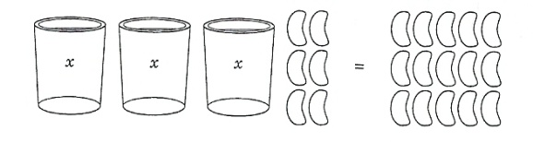

**What is the value of *x*? ­­­­­­­­­­­­­­_______________**

1. Balance Scale: What is the value of *x*? Show your work using the model below.

x

x

x

x

x

x



***x* = ______**

1. Put the steps in the order used to solve the equation:

=

1. Add -4 to both sides
2. Divide the circles equally among the cylinders
3. Cross out zero pairs

**1st: ______ 2nd: ______ 3rd: ______**

1. During the first basketball game of the year, Jacob O. scored 62 of the Jaguars’ 84 points. How many points did the rest of the team score?

A. 62 – p = 84 points

B. 62 ÷ p = 84 points

C. 62 + p = 84 points

D. 62 x p = 84 points

1. Connor charges $12 per hour for lawn work. Use, *h,* to represent the hours Connor needs to work. How many hours (*h)* does Connor need to work to earn $48?

A. $12 + h =$48

B. $12h = $48

C. $12 + $48 = h

D. $48h = $12

*Solve each equation below.*

1. *b* + 9 = 13
2. 3*d* = -99
3. 27 – *n* = 19
4. 24 = $\frac{u}{4}$
5. Write the first five terms of the sequence that follows the expression, 7*n* – 2.
6. Translate trapezoid JKLM four units down and two units to the right.



**J K**

**M L**

What are the coordinates of the translated trapezoid?

1. Reflect trapezoid JKLM across the

y-axis.



**J K**

**M L**

What are the coordinates of the reflected trapezoid?