Name:_____________________________________________________________ Date:_________

**Semester Exam Review – SWOOP!**

**Write the following in expanded form.**

1. 25

2. 06

3. 35  24

**Write the following in exponential form.**

4. 7 x 7 x 7 x 7 x 7

5. Two cubed

6. 3 x 3 x 3 x 3 x 8 x 8 x 8 x 8 x 8

**Evaluate each expression.**

7. 5 + 5  32  5

8. 7 + 8(12 – 7) 23

9. (3 + 7)2  3

**Evaluate each expression if *a* = 3, *b* = 4, and *c* = 5.**

10. 2*a*3  11. 22 – *bc* 12. 

13. The area of the square shown below is 81 square units.

Which of the following best represents?

1. the diagonal of the square
2. the perimeter of the square
3. the length of one side of the square
4. the volume of a cube with faces identical to the square

14. Which of the following is equivalent to 44?

1. 44
2. 411
3. 22 x 10
4. 22 x 11
5. Allnur and 2 of his friends went to a restaurant to celebrate Allnur’s birthday. They agreed to split the food bill of $21.36 equally. How much will each person pay?
6. Johnny’s cell phone bill is $78.94 each month. This month he was charged an additional $24.55 in text message overage fees. How much does he owe the cell phone company this month?
7. The running track behind Shea’s house is 1.9 miles long. On Tuesday, Shea ran around the track 2.5 times. How many miles does she run on Tuesday?
8. Leif guesses that $\frac{17}{25}$ of his class completed their homework last night. What percent of the class did NOT complete their homework?
9. Order the following set of numbers from least to greatest, **55%**, **0.05**, $\frac{5}{10}$**, 5**
10. Joshua has a piece of lumber that is 10inches wide. He plans to split the width of lumber into 5 equal pieces. How wide will each piece be?
11. Tira ran $2\frac{2}{5}$ miles on Saturday and $3\frac{3}{4}$ miles on Sunday. How many miles did Tira run this weekend?
12. 
13. 

1.  =
2. 
3. What multiplication expression does the model below represent?

|  |  |  |  |
| --- | --- | --- | --- |
|  |  |  |  |
|  |  |  |  |
|  |  |  |  |

Answer:

**___ x ___ = ___**

1. The number line below represents which addition expression and answer?



1. William deposited $25 in his account on Sunday, and then withdrew $48 from his account on Monday. Write and solve the expression for the change in his account?
2. A scuba diver dives 52 feet below the surface of the water, and then rises 25 feet. The scuba diver is now at what depth? Write and solve the expression.
3. (-4)(-3) =
4. 9 • (-7) =
5. (-3)(-5)(-2) =
6. (-28) ÷ (-7) =
7. – 8 – 8 =
8. 20 – (-4) =
9. 7 – (-3) + 2 =
10. -1 – 8 =
11. -5 – 4 + 12 =
$\frac{-35}{-5}$

13. Write the equation and solve by modeling.

**Equation: _______________________**

|  |  |  |
| --- | --- | --- |
|  | = |  |
|  | = |  |
|  | = |  |

***X* = _____________**

**Solve the equations below without modeling.**

41. 4x = -36

42. m – 4 = -10

43. 5 = g – 7

44. = -10

|  |  |  |  |  |
| --- | --- | --- | --- | --- |
|  |  |  |  |  |
|  |  |  |  |  |
|  |  |  |  |  |
|  |  |  |  |  |

**Use the shaded figure to answer questions 45 – 46.**

1. What fraction of the figure is shaded?
2. What percent of the figure is un-shaded?
3. Write each expression on the line provided, and then determine the value of *x*. Show your work using the balance scale below.

______________ ______________

x

x

x

x

x



**What is the value of *x*? ­­­­­­­­­­­­­­_______________**

**Questions 48 – 49, put in order from least to greatest.**

1. 40%, ¼, 80%, $\frac{2}{3}$, 0.50
2. -48, -15, $\frac{2}{5}$, -70, 1
3. **Model:** -8 + 6 (use 🞅 = 1 ● = -1)

**Determine the rule for the sequences that follows.**

1. 3, 5, 7, 9,…
2. -2, 2, 6, 10,…
3. Write the first five terms of the sequence that follows the expression, 5n – 2.

**Use the graph below to answer the questions that follow.**



**R**

**H**

1. Plot triangle A(-2, 6), B(-5, 1), C(-9, 3). If ΔABC is translated 3 units right and 4 units down, what will be the translated coordinates of A’B’C’?
2. Which point lies on line $\overline{RH}$?
3. (3, -3)
4. (5, -5)
5. (-4, 4)
6. (4, -4)
7. Reflect line $\overline{RH}$ over the x-axis and give the reflected coordinates.

 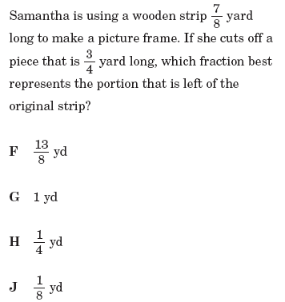

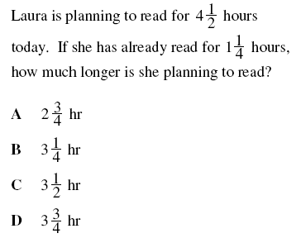 

Which expression can be used to find the *n*th term in this sequence?

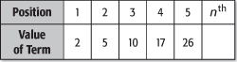  
  
A. *n*2 + 1

B. 2*n* + 1

C. *n* + 1

D. 2*n*2 + 1

**The semester exam will be ALL multiple choice questions.